***Project Report***

***On***

Weather Station using IOT

**Submitted for the requirement of**

**IEEE Report**

BACHELOR OF ENGINEERING

**COMPUTER SCIENCE & ENGINEERING**



**Submitted By:**

**NAME: Nitin Mishra**

**UID: 18BCS1988**

**NAME: Dhruv Bhattacharjee**

**UID: 18BCS2072**

**Mentor Signature**

**DEPARTMENT OF COMPUTER SCIENCE & ENGINEERING**

**CHANDIGARH UNIVERSITY, GHARUAN**

**June 2021**

**Weather Station**

Nitin Mishra

Computer Science and Engineering

Chandigarh University

*18BCS1988@cuchd.in*

# Abstract

The environmental conditions play the major effects on human beings and the weather parameters are very important roles in our daily life. Many research efforts have paid to solve the environmental problems. So the collecting of data about different parameters of the weather is necessary for planning in home and environment, and the database of weather parameters become more important for living things. In this work, two weather parameters: temperature and relative humidity have been measured by Arduino with DHT11 sensor for solving the environmental problems. The collected data from the system have been stored and transmitted to the cloud by MONGODB with Java Script programming language and then the comparison of the data collected from the sensor and the Mongo database on cloud has been made for the accuracy of the project.

***Keyword -*** DHT 11, IoT, Mongodb

# I. INTRODUCTION

Weather forecasting is done using predicting the weather and values obtained from sensors or instruments. We human use an approach of algorithms having certain or no input and valid output. Considering there is nothing random in nature and everything around us follows a particular pattern. On the basis of these weather forecasting patterns people can take precautions on even harsh weather conditions. The wireless arduino weather station has a capability of working on low power. Hence it is not much dependent on power source. The device is also made of low cost items and around ±1 unit error accuracy. As an application, a normal person can place this device at various places like in his backyard garden for soil moisture and rain water readings, indoor swimming pool for the maintenance of water temperature and humidity in air. This weather has an external feature of a website access all around the world. It attempts to show live feed of readings from that environment where the result is required.

Dhruv Bhattacharjee

Computer Science and Engineering

Chandigarh University

18BCS2072@gmail.com

DHT11 is a digital sensor with built-in analog-to digital converter. It consists of both temperature sensor with negative temperature coefficient and humidity sensor. So, it has been used to detect the temperature and relative humidity of the desired environment. Arduino reads the output from DHT11 first and then the data collected .By using MONGODB, these data are transmitted to the cloud to make the sharing data with the others, and the predicting the weather condition of specific area[2][8].

# II. RELATED WORK

S. Adnan et.al proposed “Low Cost Embedded Weather Station with Intelligent System” using reflective optical sensor, 1-turn continuous potentiometer, low-power linear active thermistor. All sensors being used were basic type sensors, so the cost of the system was reduced. And

“Design of Weather Monitoring System using Arduino Based Database Implementation” to measure and store temperature, humidity and wind speed.

Door closing system was designed for the purpose of Heavy rainfall.

# III. BACKGROUND THEORY

Weather forecasting normally tells people the weather conditions for a certain place and a certain period of time. However, the forecasting sometimes cannot predict precisely, especially in a particular case. For example, strong wind during winter would make the actual feel temperature much lower than what it is. To support the solving these problems, the weather forecasting station has been built and tested. Control system, embedded system and wireless communication are essential parts in weather

station[9][11].

## IV. Working Principle

## The device works by taking readings from various sensors at different pins in arduino microcontroller. For this purpose we’ve used an arduino compatible WiFi shield stacked upon our arduino microcontroller which adds up extra functionality to our arduino board. It increases the scope of this project. The various sensors are attached to the microcontroller each of them taking 5V input from arduino except one pressure sensor requiring 3.3V using a 3.3V pin out from the board. All the sensors are connected using a breadboard. For temperature sensor to prevent any damage or unstable behavior a 10kΩ resistor is attached in parallel to the temperature sensor on the breadboard. We’ve used DHT11 temperature sensor to get the temperature and humidity readings connected to digital pin 7 on board for input signals. It gives us continuous reading of surrounding environment in the range of two to three seconds. A raindrop sensor module is also attached from analog pin on arduino to take input signals from the sensor. The sensor detects either there is any rain or not in terms of values.

## The raindrop sensor module comes with a potentiometer attached to it. For simulation purpose we can check it by putting some water droplets on the board and we can see the readings fluctuating. BMP185 pressure sensor module is also attached to get the pressure readings in an environment. Because of its low cost it doesn’t affect the overall system. We know that pressure varies with the altitude. Hence it could be used to measure the altitude too. One more sensor attached which is soil moisture sensor module, which when dipped within a humid wet or dry soil fluctuates accordingly. It detects how much moisture is present in the soil.

## For quick representation purpose it could be checked with moistening the board by dropping some water. It consists of two tongs like rod for sensing the moisture so that it could be added within the soil and take readings. The other part of the system is wireless connectivity. We’ve attached a cc3000 wifi shield over the arduino to connect it to the local internet connection providers and connect. Its job is to transmit the data to a website linked to it and visualize the data over there for every minute or thirty seconds. Since it is a shield and not a breakout board we don’t have to make particular connections for each of IRQ, VBAT and CS. It makes our circuit less wired and neat. It has its own mac address and transmit to the web server. There are many benefits of using this shield over other wifi circuit modules present there in market as it can accept DNS where others require IP address as well as good circuit components and inbuilt antenna. It also has great libraries and support all around the world. The website for this project is an open source IOT(Internet of Things) website named Thingspeak by a community of Mathworks. So it provides further facility to add code in Matlab and various function to get knowledge

The information obtained from the readings on the server. The website provides its DNS. On the Thing speak website, the first step is to register for the account. After registration, create a channel which will be for your device. A channel is made for taking all the information you want to display update send or receive. It is used for interaction between arduino and your channel. While creating the channel, specify or check the number of fields for data you want to visualize or post on the server. Thingspeak website provide API write key and API read key for each of its own purpose. In order to send or update information regarding our device in live feed we will use API write key and specify in our code while making requests to the website.

## A. Control System

Measuring, comparing, computing and correcting are four functions in control system. The measuring is completed by detector, transducer and transmitter. Comparing and computing are within the controller and the correcting is with final control element.

## B. Embedded System

Embedded system consists of hardware, software and other parts to perform specific function. Personal computer has general purpose and is able to do many different things. The embedded system is the system within a larger system. Modern cars and trucks contain many embedded systems. One embedded system controls anti-lock brakes, another monitors and controls vehicle’s emission and a third displays information on the dashboard.

## C. Wireless Communication

The transfer of information between two or more points is called wireless communication by electromagnetic waves. Wireless sensor networks are responsible for sensing noise, interference and activity in data collection networks. This allows us to detect relevant quantities in monitor and collect data, and to perform decision-making functions.

Wireless data communications are used to spin a distance beyond the capabilities of typical cabling in point to-point or point-to-multipoint communication, to provide a backup communication link in case of normal network failure, to link portable or temporary workstations, to overcome situations where normal cabling is difficult or financially impractical, or to remotely connect mobile users or networks[5][10].

# V. EXPERIMENTAL DETAIL

Arduino is an open source device, a prototyping board consisting of ATmega328Pmicrocontroller providing a 5V and 3.3V output voltage options. It takes input voltage from either connecting USB to your computer or either using a coaxial cable using a portable power supply. The Arduino board is also capable of reading Twitter messages and respond in order to that. On the arduino you can upload sketches using Arduino IDE. Arduino comes in various flavours and according to needs like Uno, Mega, Yun etc. In this instrument I’ve used Arduino unoboard. It is cheap and feasible. Also it is good to start as a beginner. It has 14 digital input/output pins, 6 analog inputs and a reset button. It takes input voltage in between 7-12V.

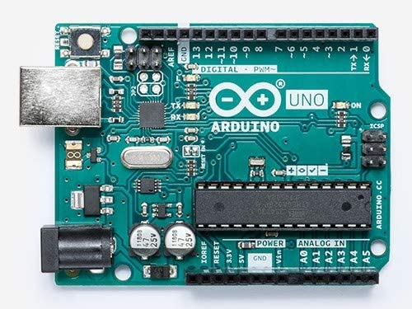

## Figure 1. Arduino

The proposed system consists of (i) temperature sensor, (ii) humidity sensor, (iii) data input from hardware sensors and (iv) data output to the cloud for sharing with the others.

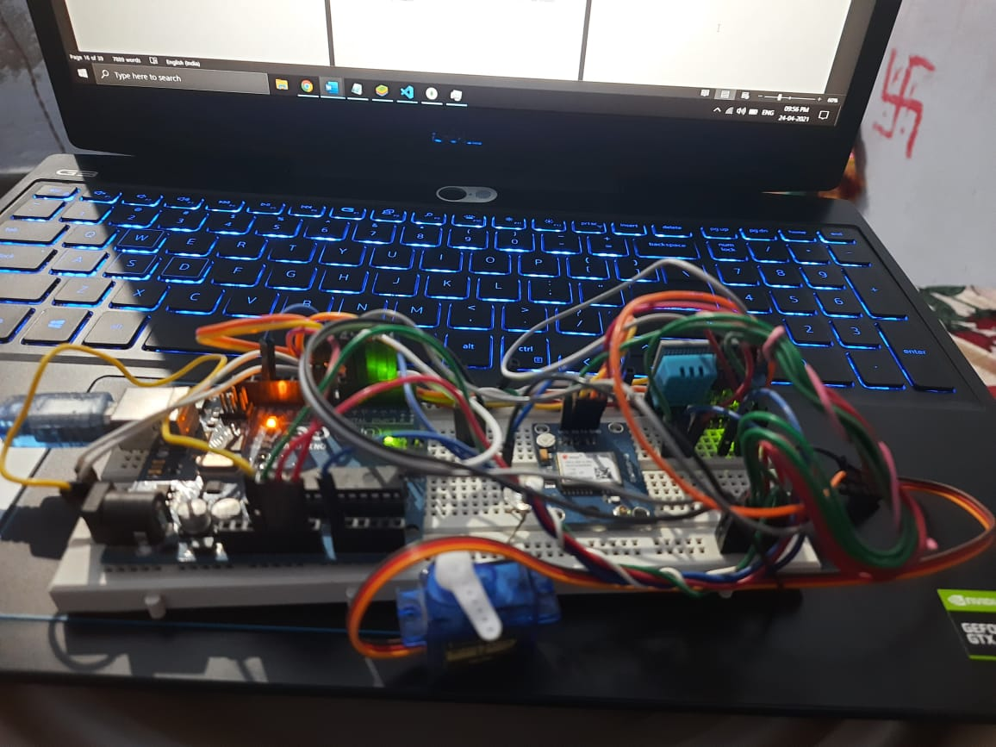

## Figure 2. Proposed system

In this proposed weather data collected system, DHT22 has been used for temperature and humidity of the environment. It is a digital sensor with an inbuilt analog-todigital converter (ADC) and the data can be transmitted through wire up to 20 m away fromArduino. It consists of a humidity sensing component, a NTC (negative temperature coefficient) temperature sensor and an IC on the back side of the sensor. It is necessary to put on 10 kΩ resistor between pin-1 and pin-2 of DHT11.

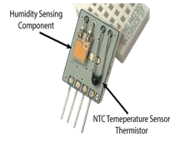

**Fig 3 DHT11**

The weather data such as temperature and humidity ,have been collected by using DHT11 with the aid of Arduino by Java Script. The first part creates the database (“test”) and the collection (“forecast_collection”) which apply the connection to the cloud. For the data sorting on CLOUD, the first creates the variable “insert” for temperature and humidity. When the term “data inserted” appears, the data value can be inserted, and it is necessary to create ID on cloud. The duration time between one-data and another is 10 s[3][7].

**Raindrop sensor module**

The rain drop sensor module is a sensor which is used to detect whether there is any rain or presence of rain weather near surrounding. It is a tool for rain detection. The module consists of a rain board on which droplets can be detected, a potentiometer attached to adjust the sensitivity for it and a LED to show the power indication. It gives only analog output. It is connected to analog pin A0.

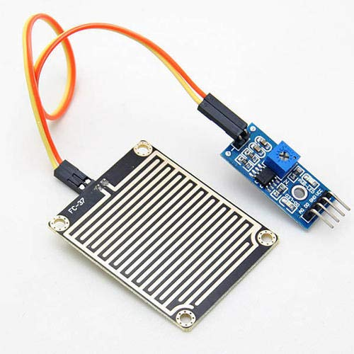

**Fig 4 Raindrop Sensor**

MongoDB is a cross-platform, document oriented database that provides, high performance, high availability, and easy scalability. It works on concept of collection and document. MongoDB is also a NoSQL type database. NoSQL is not a relational database. It provides more flexibility, since all records are not restricted by the same column names and types defined across the entire table

Database is a physical container for collections. Each database gets its own set of files on the file system. A single MongoDB server typically has multiple database. To store the weather data, “test” database must be created on cloud. Collection is a group of MongoDB documents. It is the equivalent of an RDBMS table. A collection exists within a single database. In this work, “forecast_collection” collection has been made under “test” database

.

In the proposed work, “forecast_collection” collection of “forecast database” has been created for temperature and humidity data.MongoDB can be used for “BIG DATA” in its collection of respective database. It is a document database in which one collection holds different documents. Number of fields, content and size of the document can differ from one document to another, and then data is stored in the form of JSON style documents.

For the running program of node.js, it is necessary to make the command “node nodemongodht.js”. In this work, there are three programs such as “nodemongodht.js,

“package.json” and “package-lock.json” in “projectTest” directory.

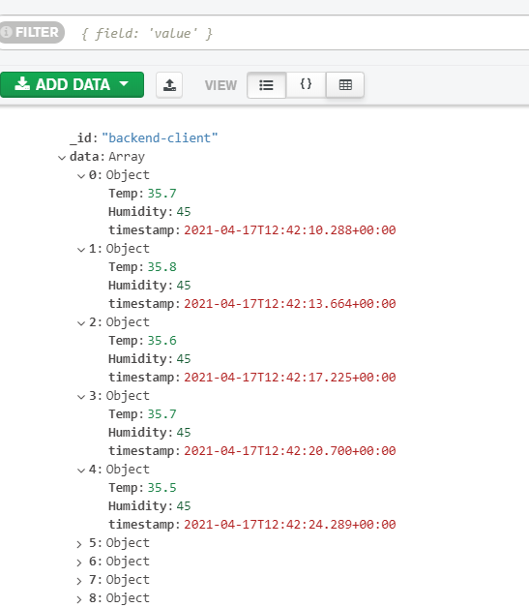

## Figure 5 Output data of the system

As shown in Fig. 9, the first data output of temperature is 24.4oC and its humidity is 57.8%. The second data will be produced within 10 s after the first output. The temperature and the humidity data of the desired environment for specific duration time are continuously collected by the proposed system.



## Figure 6 Temperatures & Humidity on Cloud

It is now seen that each document is printed in JSON style. The temperature and humidity

. **Sensor Data**

As shown in the data list on Mongo-cloud, the identification numbers (Object Id) are not in ascending list. So, it is necessary to get the careful data sorting for the comparison between the sensor output data and the data on the cloud. In the above description, every row has a unique objectId. The output clearly shows that all of the documents are printed in JSON style. JSON is a format called JavaScript Object Notation and is just a way to store information in an organized, easy-to-read manner. The

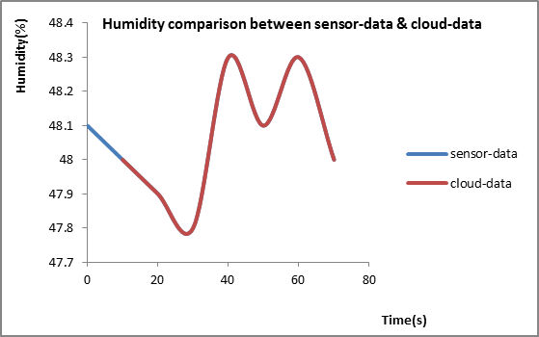

### Figure 7 Humidity comparison between sensor-data and cloud -data

“forecast” database with “forecast_colllection” collection on cloud for temperature and humidity .When the temperature is less than 26oC and the humidity is greater than 80%, there will be expected to rain in 30 minutes.

### TEMPERATURE AND HUMIDITY

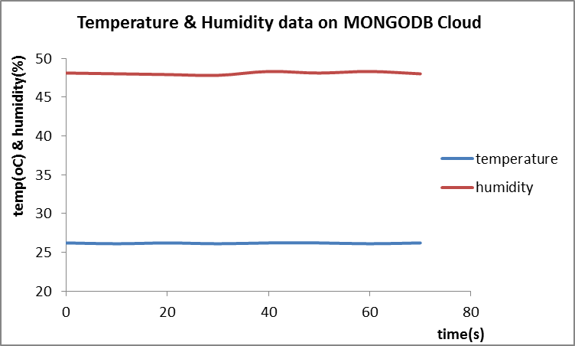

**Figure 9. Temperature and humidity on cloud**

# V. CONTRIBUTION

The proposed system has been designed to create the low cost weather station to get the information of real time weather condition and easy to install to achieve the weather data of a specific area. And then the data can be used to share to the others by using MONGODB with node.js.

# VI. CONCLUSION

Weather prediction is a very important factor, which forecasts the climate in a region based upon the values of weather parameters. So the calculated results from this system can be used in forecasting the weather of that locality for a period of time. This research makes the understanding concepts of humidity sensor and temperature sensor of DHT11 according to the construction of them, and then how to create the MONGO database on cloud of the weather parameters of the specific area. The data from sensor are transmitted to sever where they can be viewed globally which will be easily accessible to everyone. All the weather parameters were successfully displayed via MONGO database which are accessible by both administrator and users. Because there is no concept of relationship in MongoDB, a document database, in which one collection holds different documents and it can deal with big data. The comparison between sensor data and cloud data has been made for the determination of the accuracy of mongo-node.js on private-cloud. The system can make to solve the environmental problems due to the weather condition for living-things and non-living things.

# REFERENCES

**[1]** Adnan S, Yulong L, Mohan Z, Selim A, 2014, “Low Cost Embedded Weather Station with Intelligent System” (USA: Michigan)

**[2]** Aguado E & Burt J, Understanding Weather and Climate, 6th ed. Boston [Mass.]: Pearson Education, Inc., (2013).

**[3]** Avid Kopec, 2019, “Classic Computer Science Problems in Python” (New York: Manning Publications Company)

1. Hamid F, Rahman W, Mohd Nizar H, “Humidity Sensors Principle, Mechanism, and Fabrication Technologies”, *IJIRCCE,* *March 2015*
2. Kodali R & Mandal S, “IoT based weather station”, 2016 Interna-tional

Conference on Control, Instrumentation, Communication and Computational Technologies (ICCICCT), Kumaracoil, India, pp. 680-683, (2016).

1. Narasimha Karumanchi, 2016, “Data Structure and Algorithmic Thinking with Python”, (Bombay: CareeMonk Publications)
2. Peter Farrell, 2019, “Math Adventures with Python”, (San Francisco: no statch Press)

**[8]** Ruano AE, Mestre G, Duarte H & Silva S, “A neural network based intelligent weather station”, 2015 IEEE 9th International Symposi-um on Intelligent Signal Processing (WISP), Siena, Italy, pp. 1-6, (2015).

**[9]** Sarmad Nozad M, “Design od Weather Monitoring System Using

Arduino Based Database Implementation”, *Journal of*

*MultidisciplinaryEngineering Science and Technology*, Vol.4, Issue 4, April-2017

**[10]** Satyanarayana KNV, Reddy SRN, Sai Teja PVYN & Habibuddin B, “IOT Based Smart Weather Station Using Raspberry-PI3”, *Journal of*

*Chemical and Pharmaceutical Sciences*, Vol. 2016, No. 10, pp. 1-6, (2016).

**[11]** Stefano Z, 2018, “Wind Direction Extraction from SAR in Coastal Areas” (Italy: Padova)

**[12]** Yash M, Anshika M & Bhateja D, “Correlation among environmental parameters using an online smart weather station system”, India

Conference (INDICON), 2015 Annual IEEE, New Delhi, In-dia, pp. 1-6, (2015).